MINE!!! Script

How to use this script:
- First set a timer to 52 minutes(when you start playing the game)
- Take a piece of paper and put a big E on the top it will be your inventory
- One important thing is that the player can’t move

Main Game:
Remember one thing 1minute=1hour

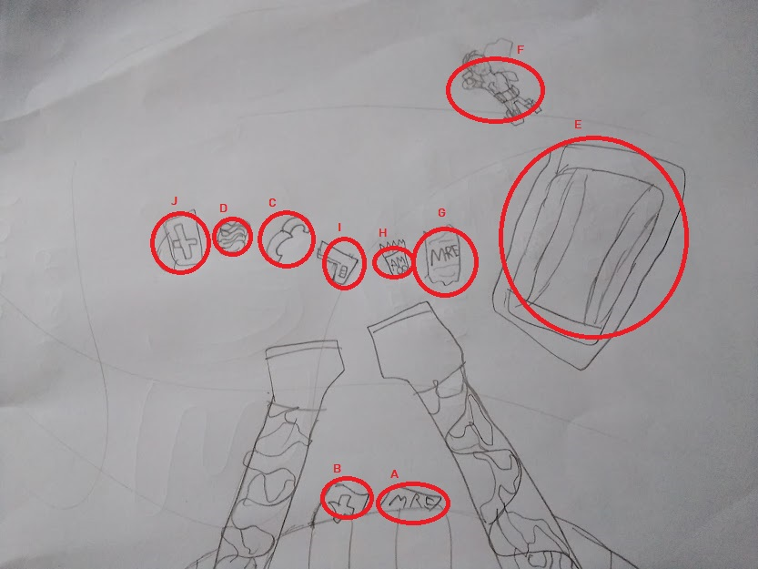

ITEMS:
A: is a pack MREs or food can be only used 3 times
B: is personal medkit
C:is knife
D:is pills
E:is an empty backpack
F:is an ded man
G:is another pack of MREs or food can be only used 2 times
H: is all the bullets you got which is 6 bullets or shots
I: is a gun
J: is a medkit

How the game will go for 52 minutes
- Nothing
- Nothing
- Nothing
- Nothing
- Nothing
- You get hungry
- Night falls
- A wild animal attacks you
- Its morning
Repeat this whole thing till its 50 minutes

50. You almost move but a man catches you and tells “Remember”
51. A fellow patrol finds you and he tells “help is on its way”
52.then you see 2 mine defusers they help you

Then you say to the player MINE!!!

