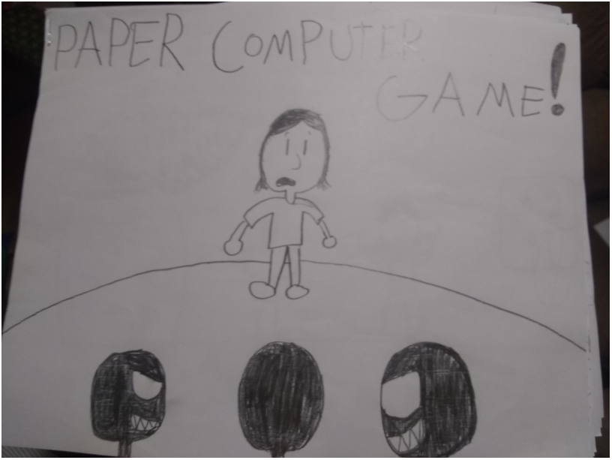Backstory: You are playing as Xaq, he is going over to his friend Chris’s house for a sleepover but when he steps inside something’s off… Chris isn’t there but his parents are but even they are off because suddenly their eyes start to glow red and then they CHASE YOU UP THE STAIRS! So you start running and you lock yourself in the bathroom but they are banging on the door!
Notes: you can go back to different screens but if a page says you can’t then well… you can’t
This PCG uses a cool system for attacking I made up called “one move attacking system” where if an object or enemy can attack you and its says “(one move attacking system)” and if then if the host says “Blank is attacking, you have one move to get out of the way or kill it” or something along the lines of that, then the player can do one thing or use one item to get out of the way or kill it. If the host says that it will not work then the player dies.
there will also be links for the music of each screen (i didn't make the music and most of it is from earthbound!). Link:
https://www.youtube.com/playlist?list=PLIh59i5bkCnE4PdpBkQXlphvtwwrm5gMr

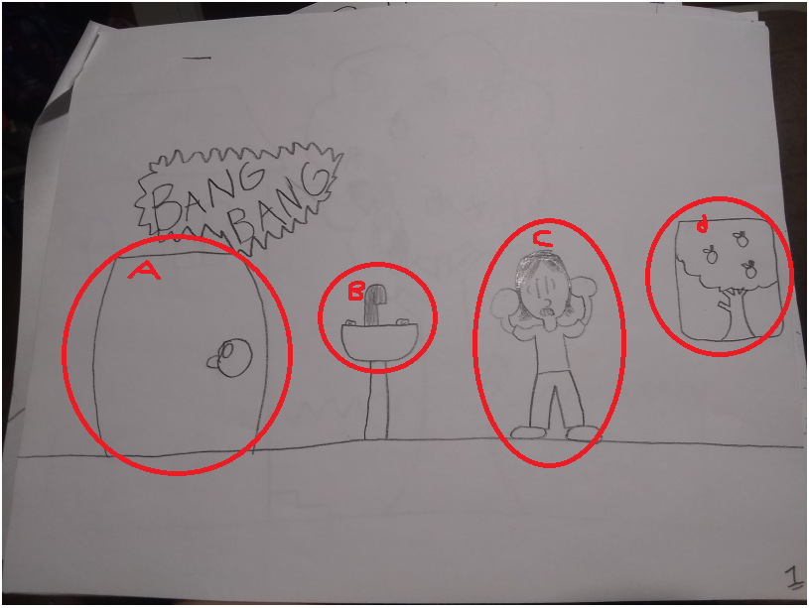
- the door: if you try opening it you will die
- The sink: you can turn this on and get water but you will need something to hold it in (you can’t just put it in your inventory). Things you can hold it in: an apple that you can hollow out (that’s on page 2) and the inflatable boat (that’s on page 3)
- Xaq: the player
- The window: to get to the next screen you climb through the window

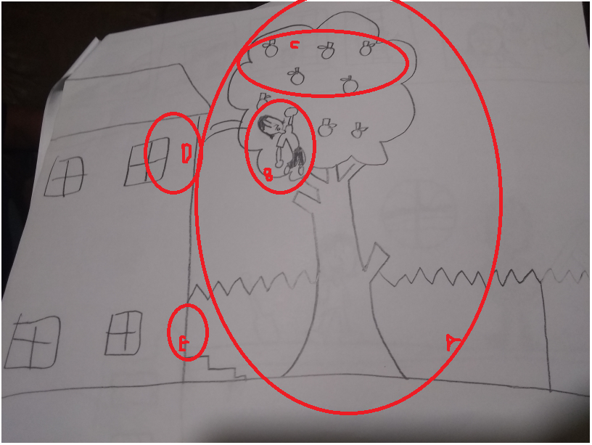
- The apple tree: this is the apple tree in Chris’s front yard; you can climb up and down it.
- Xaq: The player.
- Apples: the player can get up to 8 apples in total.
- The window: you can go back to the bathroom through this.
- The front door: its locked and you can’t go in.

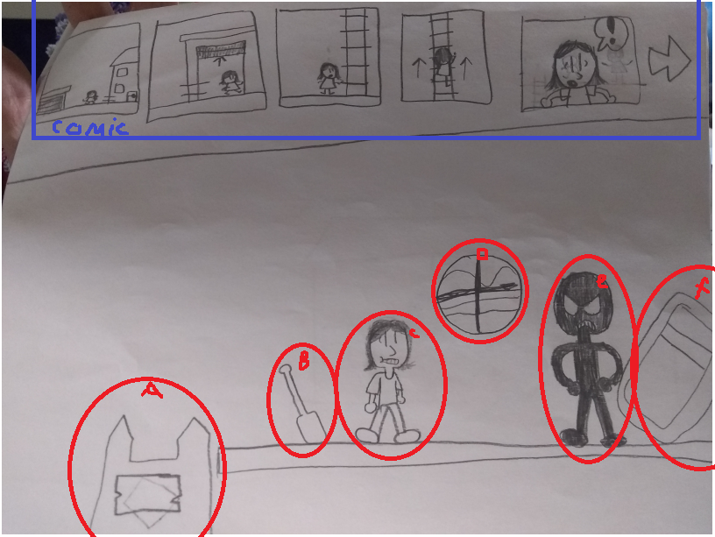
- The ladder: takes you back to the last screen if you have defeated the neighbor; if not, then the neighbor will kill you because you didn’t run away in time.
- The paddle: to defeat the neighbor you need to get the paddle and hit him on the head which will knock him out.
- Xaq: the player
- The window: the way to get out if you have defeated the neighbor.
- The neighbor: you can ONLY get pass the neighbor if you hit him on the head with the paddle. No amount of talking to him to get him to be on your side.
- The inflatable boat: you can only get this item if you have defeated the neighbor; this is a key item because it gets you across the river that goes to the castle (page 5) and saves you from the fall (page 9).
*COMIC: make sure to show the player the comic first* It shows Xaq leaving his house and going to his neighbor’s to ask for help but he ALSO has red eyes!

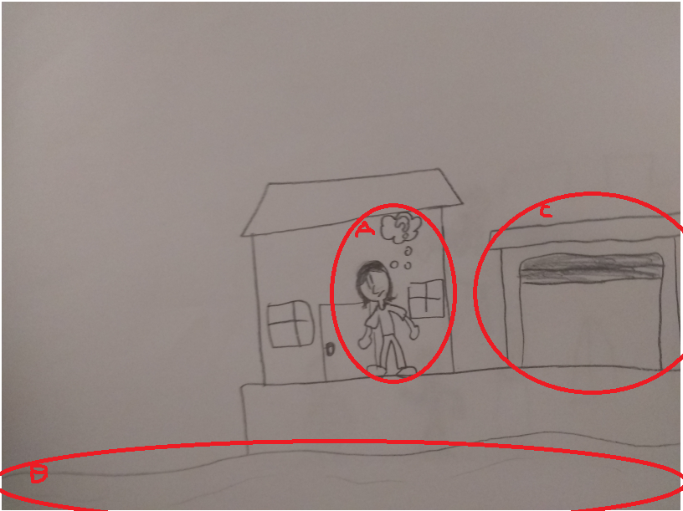
- Xaq: The player
- The river: if you have the boat then you can use it to go to the next screen.
- The garage: this will take you to the last screen

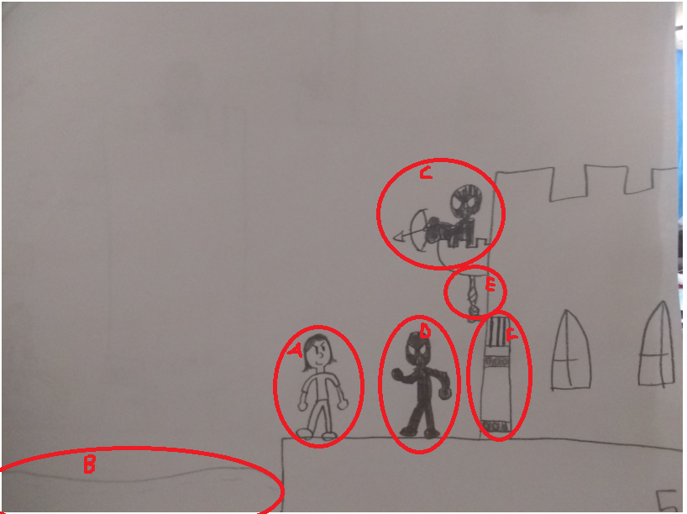
- Xaq: the player
- The river: the player can use the boat to go to the last screen
- Sniper: they can shoot you from above: can be killed by the paddle (if thrown), and your fist if you get them down by taunting them. (one move attacking system)
- Guard: like the sniper but it can’t shoot and it only punches.
- Rope: if all the enemies are defeated then the player needs to pull the rope to open the door.
- Door: if the door has been opened by the string then the player can go into the castle which leads on the the next screen

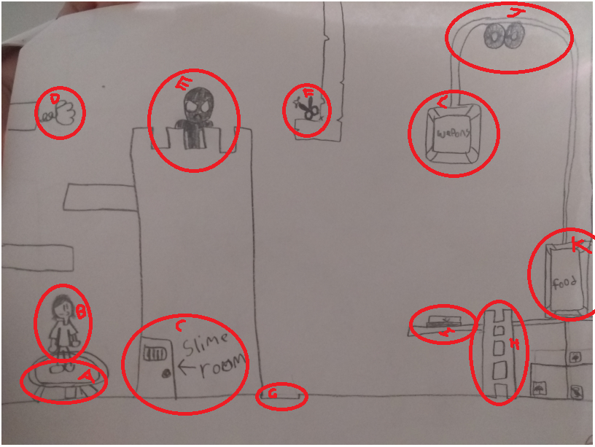
- Trampoline: the player can use this to bounce up to the mini tower in front of them.
- Xaq: the player
- Slime room: this room is full of green Nickelodeon like slime, if the player goes in (no screen) then they will get 1 bucket of slime (only one, you can’t get multiple.
- Boxing glove trap: if the player is close to it then the host can say (one move attacking system)
(Can’t be killed) (Only activates once)
- Guard: the guard has to be killed to move on.
- Scissors: the player needs this item to complete a puzzle later on.
- Mini hole: if the player just try’s to fall down they will die, so they need the bucket of slime to pore down the side of the mini castle so they can slide down and not get hurt (after using this item the player will lose the slime and the bucket). OR the player can use the boat or the apple with water in it, pore the water down the little hole, and totally MLG water bucket it!!!!!!!!!!! (ha ha funny mine craft referents)
- The ladder: the player can climb it. (mainly for decoration)
- A button: if pressed then the pulley will go down. (if the player stands on it then they will get crushed by the weapons box and die)
- The pulley: this will pull the boxes up and down with the lever. The rope and be climbed and cut with the scissors.
- Food box: if the player opens it, they will get one microwavable TV dinner that can’t be eaten unless its cooked.
- Weapons Box: if the player opens it they will get a sword and a bow with 10 arrows
*NOTE* after the player goes down the mini tower they can’t go back to any of the last screens.
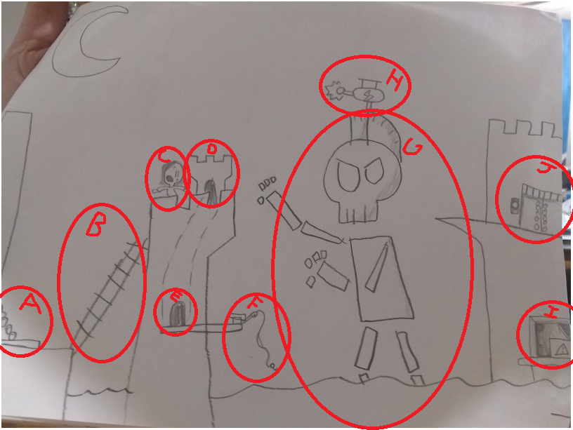

- Exit Door: The Player can use this door to go back to the last screen.
- Ladder: The player can climb it to go to the top castle.
- Xaq: The player.
- Mini Door Top: This will take the player to the door on the bottom.
- Mini Door Bottom: This will take the player to the door on the top.
- Fishing rod: The player can’t put this in their inventory but they can still use it to fish the bones out of the water if you have killed the skeleton.
- The Skeleton Boss: There are two ways to defeat him: you can kill him by using your weapons or paddle, or you could become friends with him by cooking the TV dinner with the laser on his head and give to him.
- The Laser: This can shoot lasers at you. This is also what can cook the TV dinner (one move attacking system).
- Secret Box: If the player uses the boat to cross the water and opens the box they will get the baby pizza: when you get him he is in your inventory forever and you can’t do anything with him, you can’t even throw him out.
- This is the door that will take the player to the next room.
*PUZZLE SALUTION* To go to the next room the player needs to kill the boss, use the fishing pole to get the bones, and make a bridge to the other side, or becomes friends with him by cooking the TV dinner with his laser and he’ll make a bridge with his arms for you!

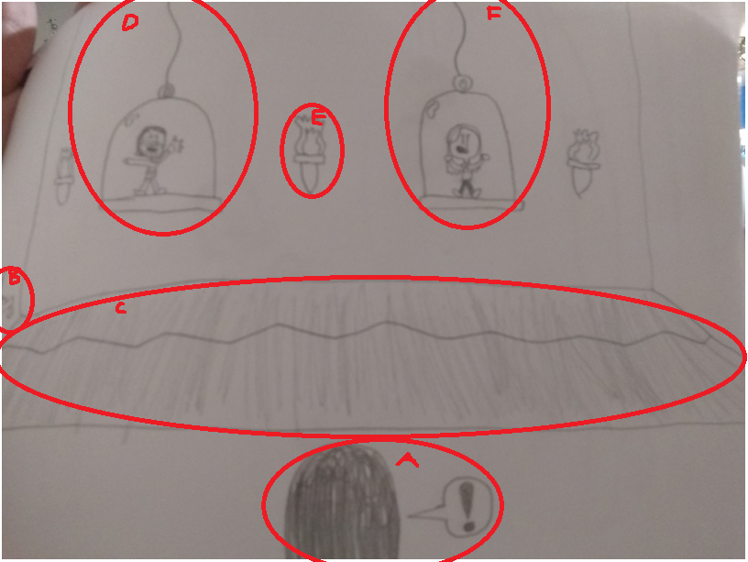

- Xaq: The player
- The Switch: I know it got kinda got cut off In the picture but just let the player know that there is a switch there. To move on to the next room and to free you friends the player needs to flip it.
- Trap Door Floor: At the start its closed, but when the switch is pressed the trapdoor opens and you and your friends fall in it
- Ari: it’s your friend Ari
- Colette: It’s your friend Colette.
- Torch (this applies to all torches in the room): these can be taken off the wall (can’t burn through the bubble cages).

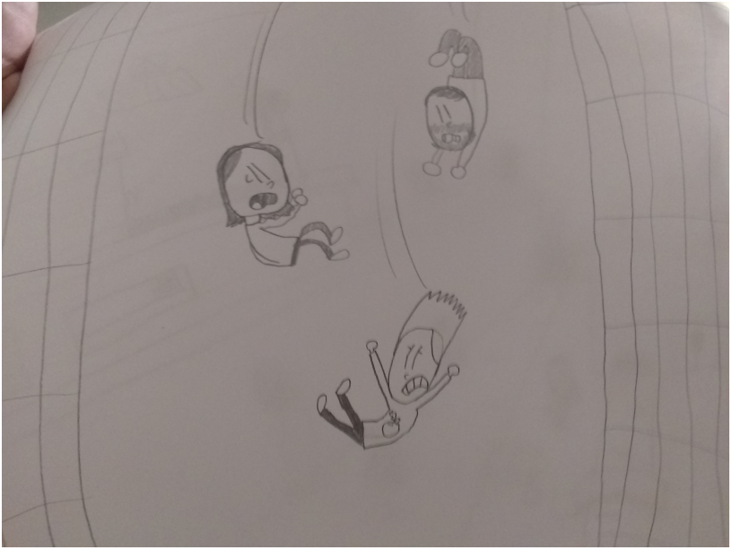
There is nothing on this screen, it's just a transition to the next one.

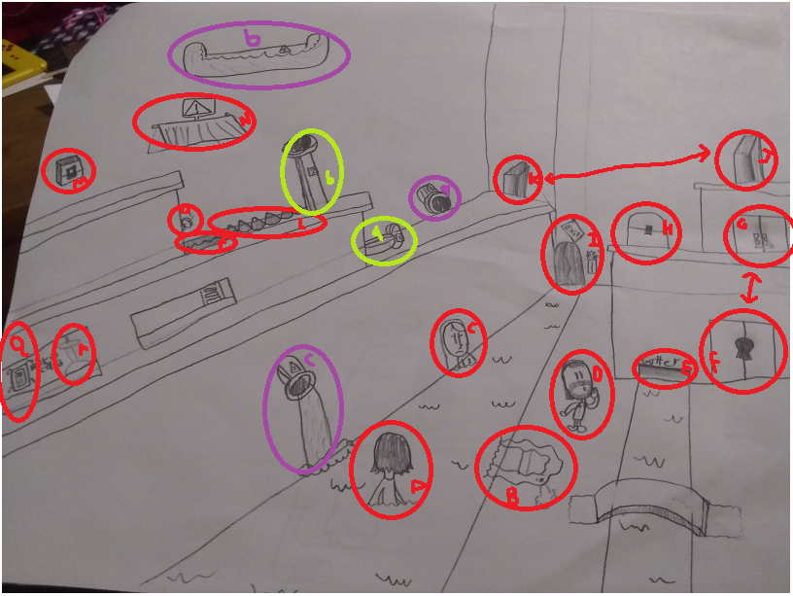
- Xaq: the player
- The raft: on your fall down the boat got a hole and is now deflating. can be reflated with the air pump.
- Colette: It’s your friend Colette.
- Ari: It's your friend Ari.
- The gutter: to open the locked door (f) you need to get the key that's stuck in the gutter.
- Locked door: you need the key from the gutter to open this door. this takes you to the next screen
- top door: by opening the locked door you can go to this door and you can also go back to the bottom with this.
- Treasure chest: inside is a trampoline… stuck in the chest. but no worries you can still jump on the trampoline while it's still in the chest.
- Exit door: this door is super strong and the only way to open it is with a special key card.
- Tunnel door 1: no key needed, goes to tunnel door 2 (k)
- Tunnel door 2: no key needed, goes to tunnel door 1 (J)
- Row of spikes: if you fall on them you'll die.
- Button: pressing this will open the trap door (O)
- Wooden platform: The Player can use this as a platform.
- Spring: player can use this to bounce out of the hole
- Trap door: Its closed but can be opened with the button (M)
- Keycard: it is keep in a case that's on the wall
- Pump: this will be able to pump air back into the boat so you can use it.
(A) Pipe A: this takes you to pipe (B)
(B) Pipe B: this takes you to pipe (A)
Pipe (A) will take you to pipe (B) which will take you to pipe (C). After using this pipe you are stuck in the lower section.
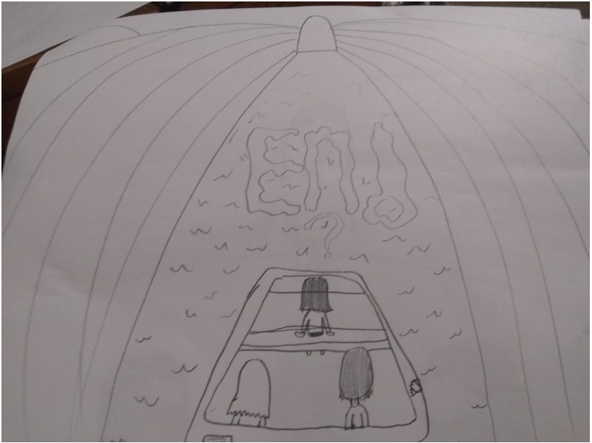

you did it but… what next

